**INFO**

**ADDRESS**

110 E. Houston St. 7th Floor, San Antonio, TX, 78205

**PHONE**

(210)555-5555

**EMAIL**

resumes@techtalentcentral.com

**LINKS**

[LinkedIn](http://www.linkedin.com/company/techtalentcentral)

**SKILLS**

Project Management Petting every dog I meet

Analytical Thinking Skills

Interpersonal Communication Skills

Coffee Drinker

Web and Mobile Design

IT Project Management

Information Technology Training Skills

**HOBBIES**

Volunteering in my community, reading books about stuff, and exploring the food scene in San Antonio

**TECH TALENT CENTRAL**

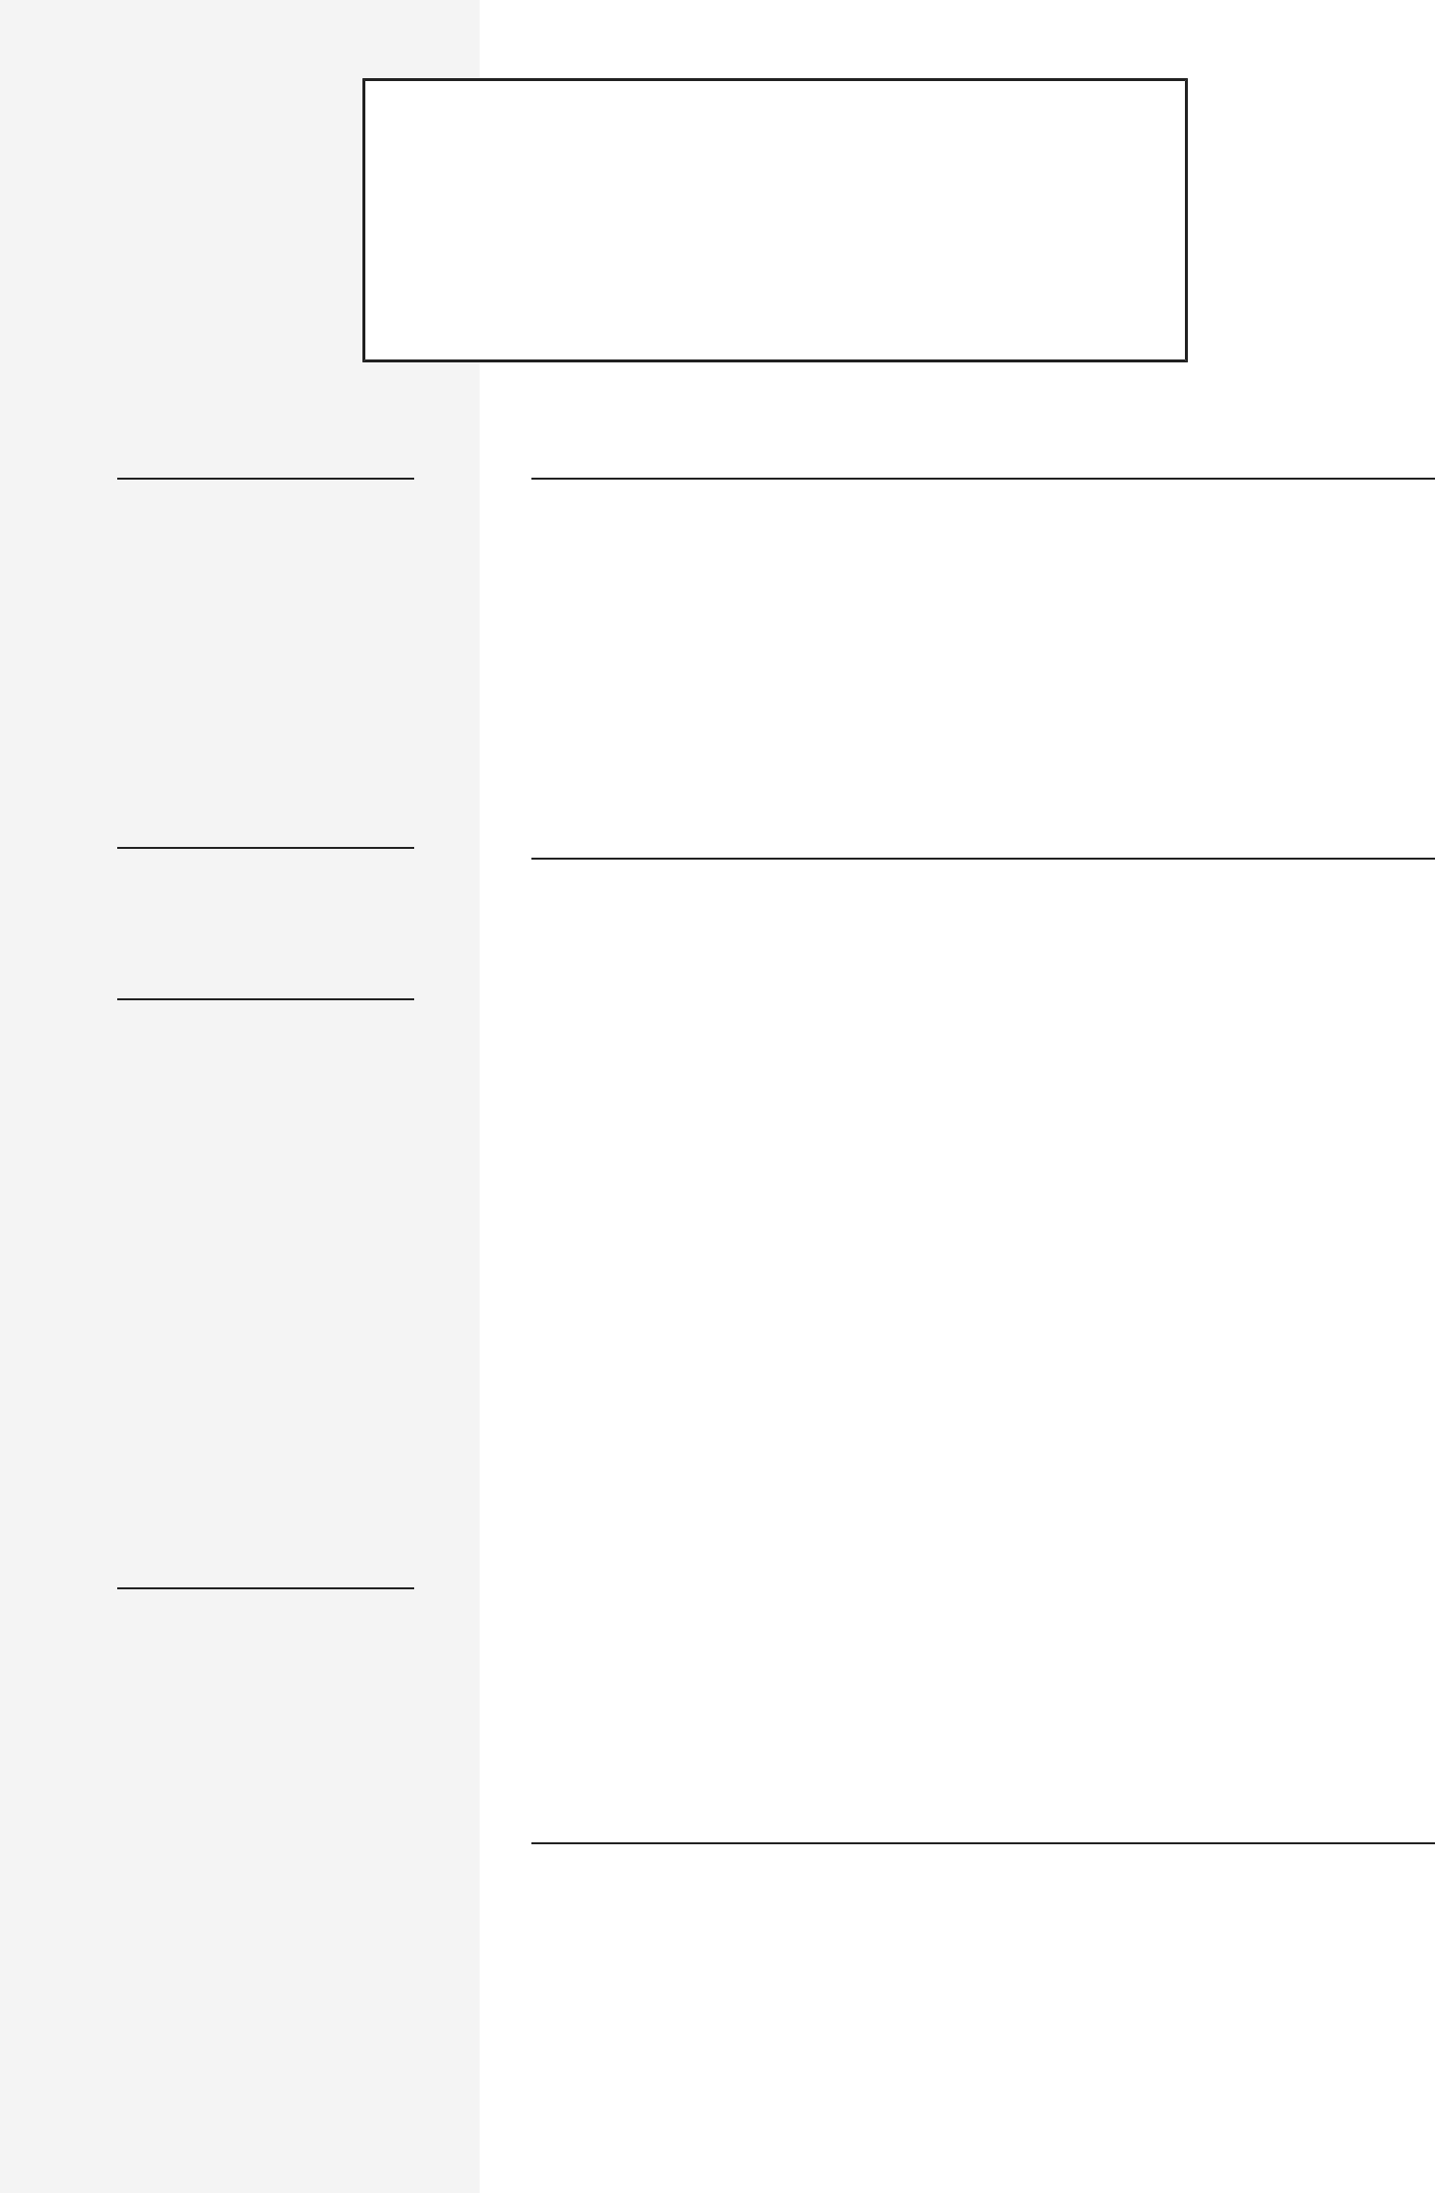

TALENT COORDINATOR

**PROFILE**

Experienced and professional *career role or job title* with over X years of valuable experience in monitoring project performance to ensure team and company success. Adept in working with software development, Agile workflows, QA, and change management. Known for continually achieving on time and under-budget performance goals. Accustomed to various demands of roles that people forget are parts of any job. Brings a motivated attitude towards success each day and the ability to establish strong and productive relationships with other company members.

**EMPLOYMENT HISTORY**

**Job Title, Your Most Recent Employer** San Antonio, TX

SEPTEMBER 2013 – SEPTEMBER 2019

* Overall responsibility and purpose in role.
* Highlight of success/milestone/achievement in role.
* Specific focus area or responsibility in role that overlaps with the new job you’re applying for with this resume
* Performance metric that highlights your success or effectiveness in the role that invites resume reader to ask you questions about it

**Job Title, Your 2nd Most Recent Employer** San Antonio, TX

SEPTEMBER 2013 – SEPTEMBER 2019

* Variation on the theme above
* Don’t just copy & paste
* This resume tells your story before they even meet you - make it compelling and easy for them to say “yes” to your resume
* Seriously, put some effort into this thing!

**Job Title, Your 3rd Most Recent Employer** San Antonio, TX

MARCH 2009 – AUGUST 2010

* If you struggle with this…
* Have a friend ask you what you do and record what you say
* Also, have them ask you what you do best in the role and to share your best day at work in this job and why it was so great.
* Listen to your recording and share some of it in your resume

**EDUCATION**

|  |  |
| --- | --- |
| **Master of Business Administration, University of** | San Antonio, TX |
| **Texas at San Antonio** |  |
| AUGUST 2016 – MAY 2018 |  |
| **Bachelor of Computer Science, University of Texas at** | San Antonio, TX |
| **San Antonio** |  |

AUGUST 2011 – MAY 2014

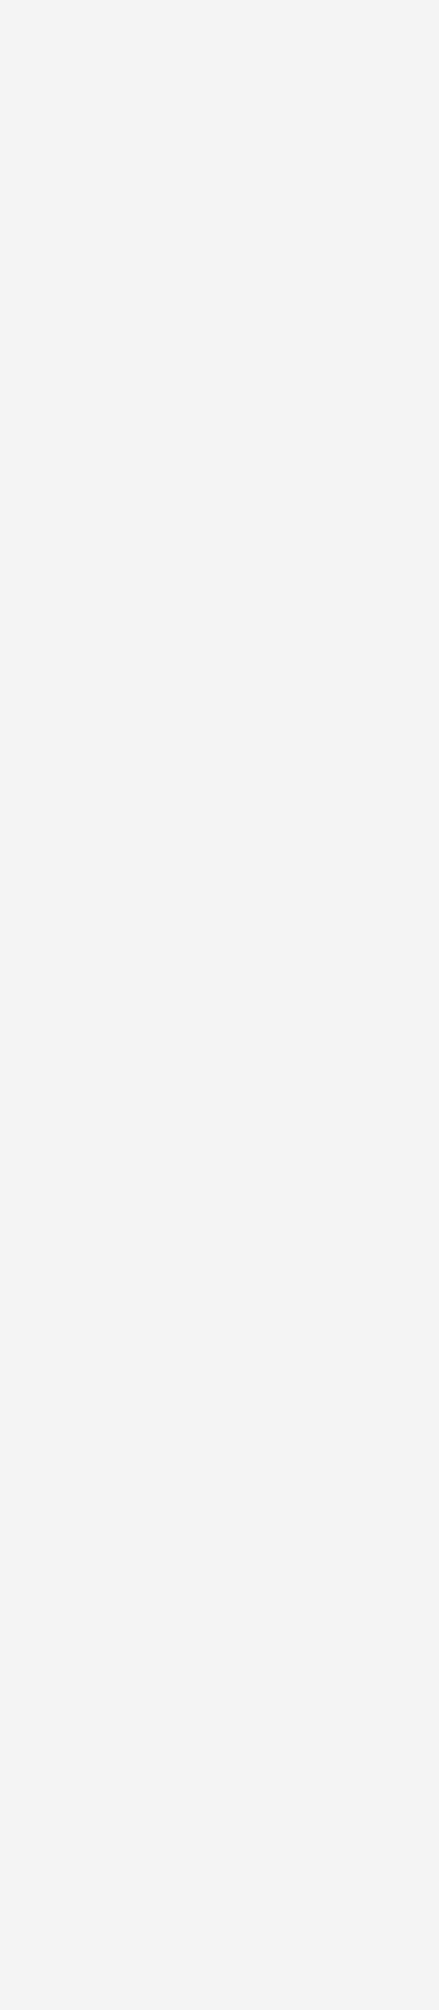**Associates Degree, Alamo Community College**

JANUARY 2007 – DECEMBER 2010

**Diploma, Local High School**

SEPTEMBER 2002 – MAY 2006

**COURSES**



**Software Development, Local Coding Academy**

JANUARY 2019 – JULY 2019

**INTERNSHIPS**



**Social Media Marketer, Students + Startups**

MAY 2019 – AUGUST 2019

**REFERENCES**



**References available upon request**

San Antonio, TX

San Antonio, TX

San Antonio, TX